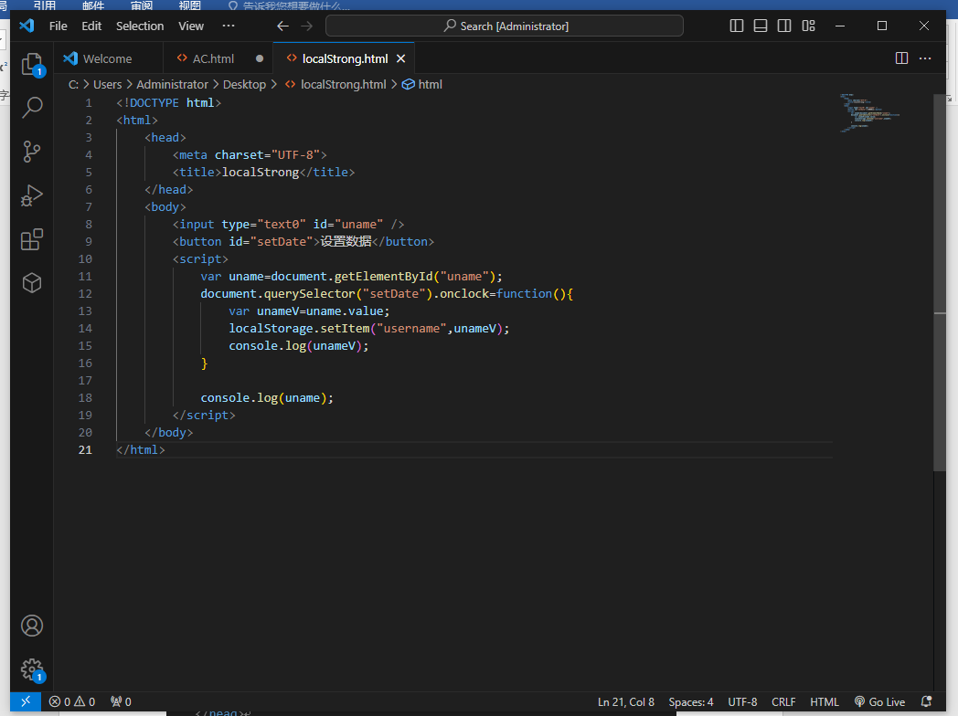

<!DOCTYPE html>

<html>

    <head>

        <meta charset="UTF-8">

        <title>localStrong</title>

    </head>

    <body>

        <input type="text0" id="uname" />

        <button id="setDate">设置数据</button>

        <script>

            var uname=document.getElementById("uname");

            document.querySelector("setDate").onclock=function(){

                var unameV=uname.value;

                localStorage.setItem("username",unameV);

                console.log(unameV);

            }

            console.log(uname);

        </script>

    </body>

</html>

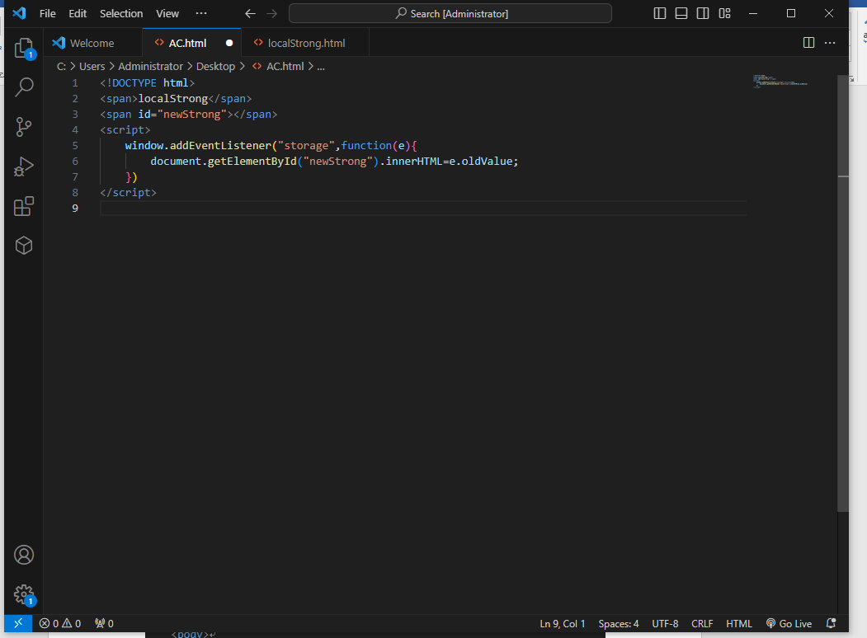

<!DOCTYPE html>

<span>localStrong</span>

<span id="newStrong"></span>

<script>

    window.addEventListener("storage",function(e){

        document.getElementById("newStrong").innerHTML=e.oldValue;

    })

</script>